Requirements

Packaging and Hardware Installation
The product will arrive at the customer’s site in a double-boxed package. When opened, the customer should be presented with the accessories package containing the system manuals and support cables. If critical information needs to be displayed to the customer a “Read Me First” document will be on top of all other materials in the accessories package.

The physical installation of the appliance should capable of being completed within 15 minutes. The primary task here is to remove the appliance from the packaging and to rack the appliance into a standard four post rack. All hardware required to rack mount the appliance should be included in the packaging.

- The hardware should be installable within 15 minutes.
- The hardware packaging should contain all required materials for installation into a standard four post rack.
- The hardware should install into any standard four post rack.

Setup and Configuration
The administrator needs to complete several tasks to configure the appliance. First, the appliance needs to be placed onto the network. Initial network configuration occurs by using a laptop and null-modem serial cable connected to serial port on the front of the appliance. The administrator uses HyperTerminal™ or some equivalent to make a serial connection with the appliance.

When the serial management interface detects that a management client has connected for the first time it walks the administrator through first time setup. It first prompts the administrator to enter a password for the ‘admin’ user on the system. After entering the password it must be confirmed by entering it a second time.

Second, the administrator is asked to configure the network parameters for the appliance. These parameters are prompted for and accepted one at a time. They include IP address for the primary LAN channel, net mask, default gateway, and DNS servers. After these parameters are entered they are displayed together and the administrator is asked if he wishes to accept the network changes.

After the initial setup is complete the administrator is placed at the main menu. The main menu contains four options:
- Change administrator password
- Change network settings
- Reboot server
- Quit

The administrator typically would quit at this point since the appliance is on the network and the rest of the configuration can happen via the mceadmin web management console. If the administrator plugs into the serial management interface at a later date they will be immediately presented with the main menu.

The following flow chart demonstrates the setup and configuration sequence via the serial management interface.

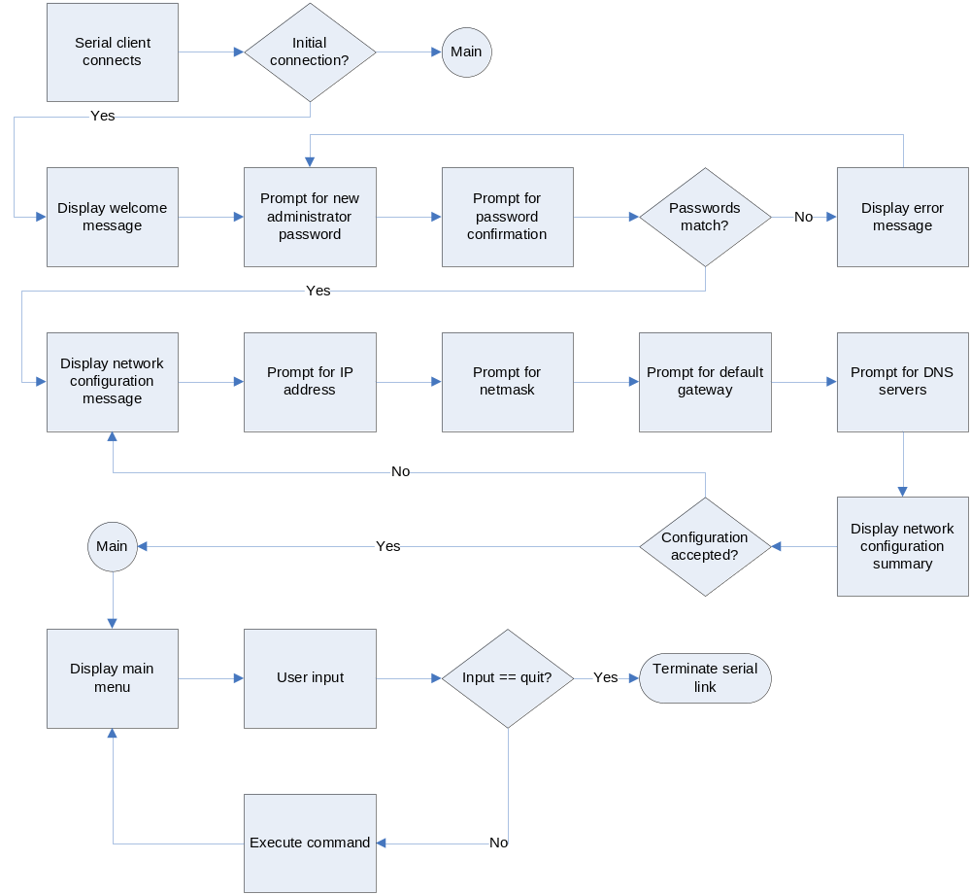

- Initial appliance configuration should occur via a serial link to a laptop.
- The serial network management interface should allow for configuration of administrator password and operating system network settings.
- The serial network management interface should be able to reboot the server.

Security
The appliance should be configured in a very restrictive security mode using IPSec. The default security settings would block inbound connections on any non-required ports. The IPSec configuration should be exposed and modifiable by mceadmin. IPSec configuration can be manipulated using the ‘netsh.exe’ command line program.

Virus scanning will be installed as part of the standard appliance configuration. The virus scanner and its virus definitions should be updatable from mceadmin. It should be possible to enable automatic virus updates allowing the virus engine to pull updates from a central repository on its own. Commercial anti-virus engines should be investigated along with open source solutions such as ClamAV (http://www.clamav.net).

Questions:
  - To what extent is the anti-virus feature really needed?
  - Should we use it to scan application archives before they are deployed?
  - Open source AV products won’t have “auto-protect” or “on-access” scanning, but then again, why would this be required?
  - What about worms?
  - What is the procedure for cleaning an infected system? Is it even possible or would the customer have to do an RMA and restore from a backup?
  - If we use a commercial anti-virus product how are virus database updates handled from a licensing perspective?

Maintenance and Updates

Backups and Recovery

Monitoring and Instrumentation

